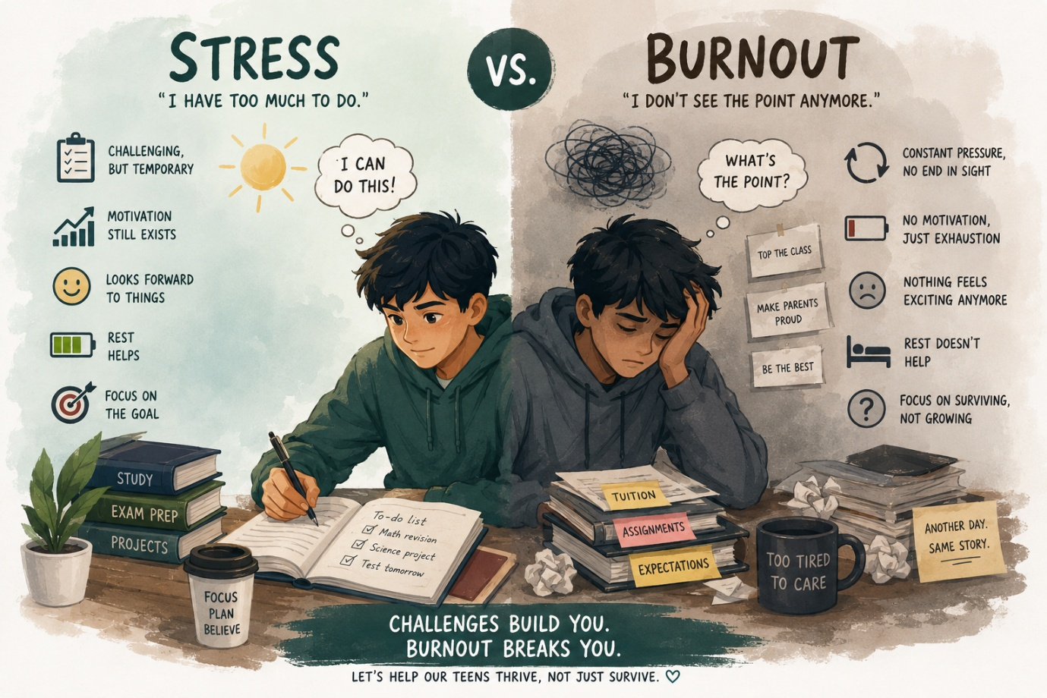
The Difference Between Stress and Burnout in Teenagers: When "Busy" Becomes "Empty"

Welcome back to the Ikigai Teen blog.

In our previous article, "Is Your Teen Burned Out? The Warning Sign Most Parents Never Notice," we explored how burnout often hides behind good grades, responsible behaviour, and a smile that convinces everyone everything is fine.

But that raises an important question:

How do you know whether your teen is simply stressed—or whether they're experiencing burnout?

Many parents use these two words interchangeably. After all, today's teenagers are expected to handle school, tuition, projects, extracurricular activities, entrance exams, friendships, family expectations, and an always-connected digital world. Feeling stressed seems almost normal.

The problem is that stress and burnout are not the same thing.

Understanding the difference could help you recognise when your teen simply needs a weekend of rest—and when they need a complete change in how they're living.

Stress Says, "I Have Too Much to Do."

Burnout Says, "I Don't See the Point Anymore."

Stress is the mind's natural response to challenge.

Imagine your teen preparing for an important exam next week. They may feel nervous, spend extra hours studying, sleep a little less, and even become temporarily irritable. Once the exam is over, however, they begin to relax. They laugh again. They meet friends. Their energy slowly returns.

Stress is demanding, but it still leaves room for hope.

Burnout is different.

Burnout happens when the pressure continues for so long that the brain and body stop believing relief is coming. The problem is no longer the workload itself. It is the feeling that the effort no longer has meaning.

Stress whispers, "I need a break."

Burnout whispers, "Nothing will change even if I take one."

That difference changes everything.

The Energy Bank Account

Think of your teenager's emotional energy like a bank account.

Every challenge—an exam, a late-night assignment, a disagreement with a friend—makes a withdrawal.

Every positive experience—a good night's sleep, laughter with friends, time outdoors, family conversations, pursuing a hobby—makes a deposit.

Stress happens when withdrawals temporarily exceed deposits.

Burnout happens when withdrawals continue for so long that the account remains empty, and nothing seems capable of filling it again.

The problem isn't that teens are working hard.

The problem is that many no longer have enough opportunities to recover.

Five Questions Every Parent Should Ask

Instead of trying to diagnose your teen, pay attention to patterns.

1. Does Rest Actually Help?

A stressed teenager often feels noticeably better after a holiday, a weekend, or a good night's sleep.

A burned-out teenager may physically rest but still wake up emotionally exhausted. The fatigue follows them, regardless of how much they sleep.

Recovery becomes harder because the exhaustion is deeper than the body alone.

2. Is the Pressure Temporary or Constant?

Stress usually has a finish line.

The exams end.

The competition finishes.

The project gets submitted.

Burnout feels different because there is always another mountain waiting.

As soon as one challenge ends, another immediately begins.

Life becomes an endless cycle of preparation rather than experience.

3. Is Your Teen Still Looking Forward to Anything?

One of the clearest differences between stress and burnout is anticipation.

A stressed teen still has things they look forward to—a weekend outing, football practice, music lessons, meeting friends, or watching a favourite movie.

A burned-out teen begins saying things like:

"I don't really feel like doing anything."

Not because nothing is available.

Because nothing feels rewarding anymore.

4. Are They Working from Passion or Fear?

Ask yourself this question:

What is driving your teenager today?

Curiosity?

Growth?

Or fear of falling behind?

Many teenagers continue performing at a high level, not because they enjoy learning, but because they are terrified of disappointing others.

Fear can be an effective short-term motivator.

It is a dangerous long-term lifestyle.

5. Have They Forgotten Who They Are Outside Academics?

Imagine asking your teenager:

"Tell me about yourself."

Would they describe their interests, values, friendships, and dreams?

Or would they only mention grades, subjects, exams, and career goals?

When identity becomes completely tied to achievement, burnout finds fertile ground.

Healthy teenagers have goals.

Healthy teenagers also have identities beyond those goals.

Why This Difference Matters

Many well-meaning adults respond to burnout as though it were stress.

They suggest better time management.

They recommend studying differently.

They encourage students to "push through."

That advice may help someone experiencing temporary stress.

For someone experiencing burnout, it often adds another layer of pressure.

Burnout isn't solved by becoming more efficient.

It is solved by rebuilding balance.

That means restoring sleep, reconnecting with meaningful activities, strengthening relationships, reducing unnecessary pressure, and helping teenagers remember that they are valuable regardless of their performance.

What Parents Can Do This Week

Instead of asking your teenager,

"Are you stressed?"

try asking,

"What has been giving you energy lately?"

The answer is revealing.

If they struggle to name even one thing that leaves them feeling refreshed, inspired, or genuinely happy, it may be time to look beyond academics and consider whether burnout is beginning to take hold.

Sometimes the goal isn't helping teenagers work harder.

Sometimes the goal is helping them feel alive again.

Final Thought

Stress is part of growing up.

Burnout should not be.

The aim is not to remove every challenge from a teenager's life. Challenges build confidence, resilience, and character.

The aim is to ensure that achievement never comes at the expense of identity, curiosity, and emotional well-being.

At Ikigai Teen, we believe success should expand a young person's life—not shrink it. When we learn to recognise the difference between healthy stress and harmful burnout, we give our teenagers something far more valuable than better grades.

We give them the freedom to grow without losing themselves.

In our next blog, we'll explore another important question: "Why High-Achieving Students Are More Vulnerable to Burnout." It's a conversation every parent of an ambitious teenager should read.

